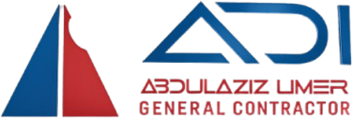
COMPANY PROFILE
Abdulaziz Umer
General Contractor
Grade 3 Building & Road Contractor · Addis Ababa, Ethiopia
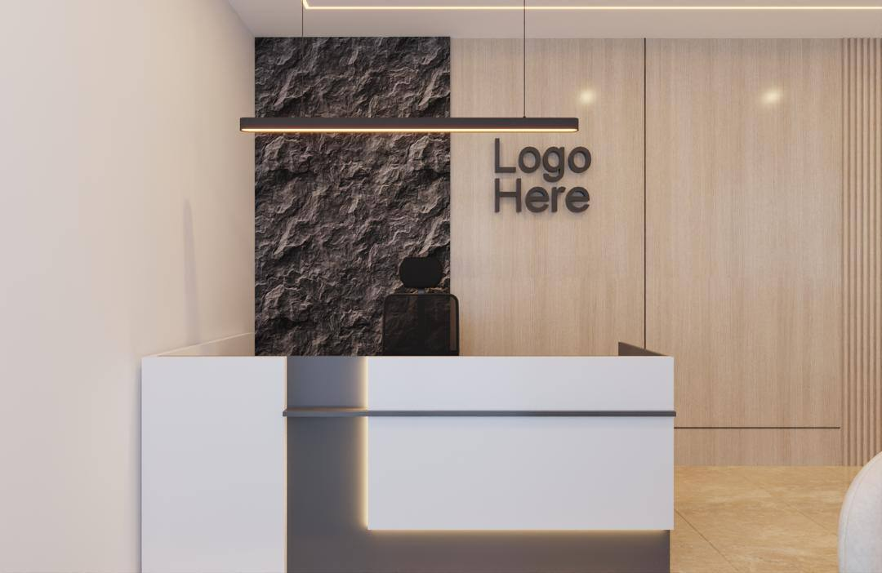
Building Ethiopia's Future

1. About the Company
Abdulaziz Umer General Contractor is a sole proprietorship registered in Addis Ababa, Ethiopia, holding a Grade 3 General Contractor license. Founded and led by Mr. Abdulaziz Umer, the firm delivers residential, commercial, infrastructure and renovation projects with precision, integrity and craft.
As a sole proprietorship, every project carries the owner's name and personal accountability. Clients work directly with the decision-maker — no layers, no delays.

2. Company at a Glance
Legal name | Abdulaziz Umer General Contractor
Founder & Owner | Mr. Abdulaziz Umer
Business form | Sole Proprietorship
License grade | Grade 3 — Building & Road Contractor
Headquarters | Bisrate Gabriel, Addis Ababa (office now open)
Sectors | Residential · Commercial · Infrastructure · Renovation
Reach | Addis Ababa & nationwide Ethiopia
Workforce | 250+ skilled workers, engineers & craftsmen
Track record | 40+ delivered projects · 12+ years of practice

3. Mission & Vision
Mission: To build durable, well-finished structures that serve Ethiopian families, businesses and communities — delivered with integrity, on time, and to a premium standard.
Vision: To become one of Ethiopia's most trusted mid-tier general contractors, graduating to higher license grades while preserving personal accountability.

4. Core Values
- Integrity — honest pricing, honest timelines, honest work.
- Quality — built to standard, finished with care.
- Precision — every measurement, every joint, every detail.
- Partnership — we build relationships, not just structures.

5. Our Services
- Residential construction — villas, apartments and G+ buildings.
- Commercial construction — offices, retail and mixed-use buildings.
- Road & infrastructure works — access roads, drainage and site works.
- Renovation & finishing — interior fit-out, remodeling and upgrades.
- Project management & consultancy — planning, costing and supervision.

6. Selected Project Types
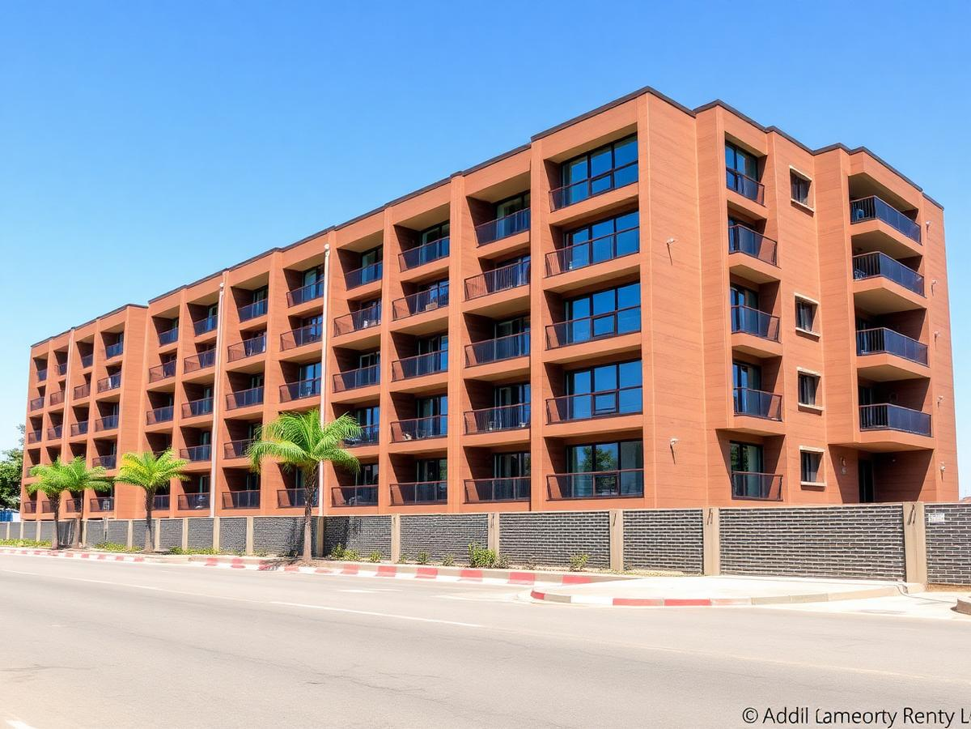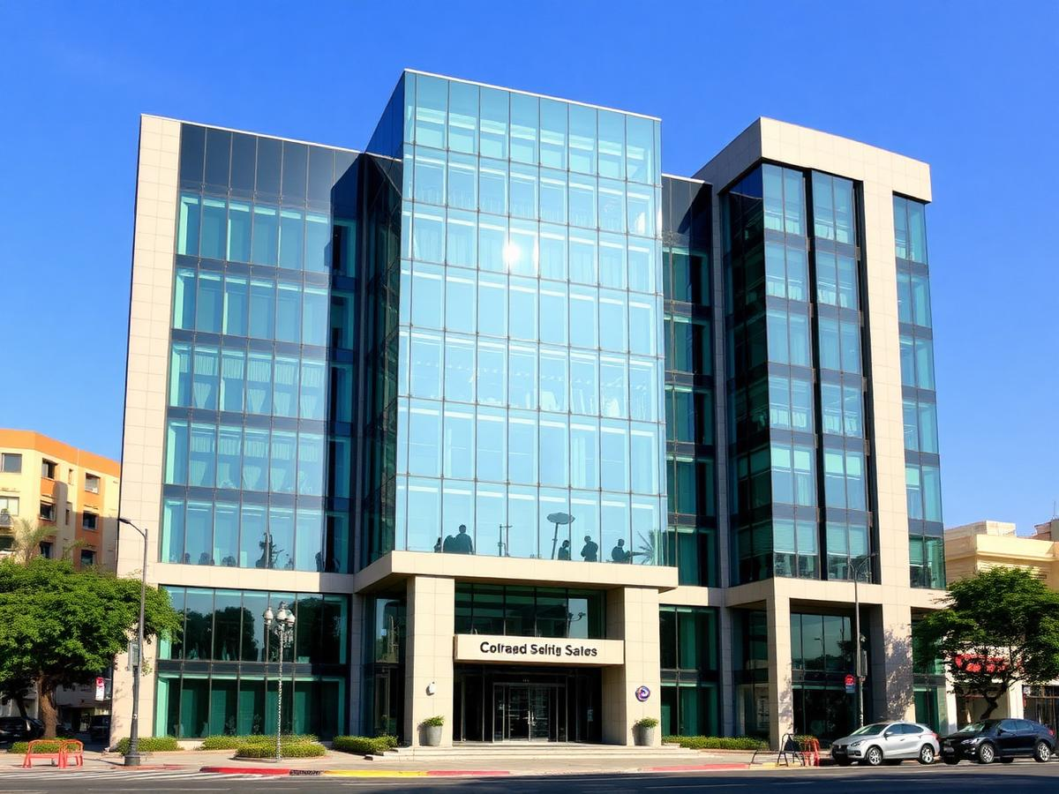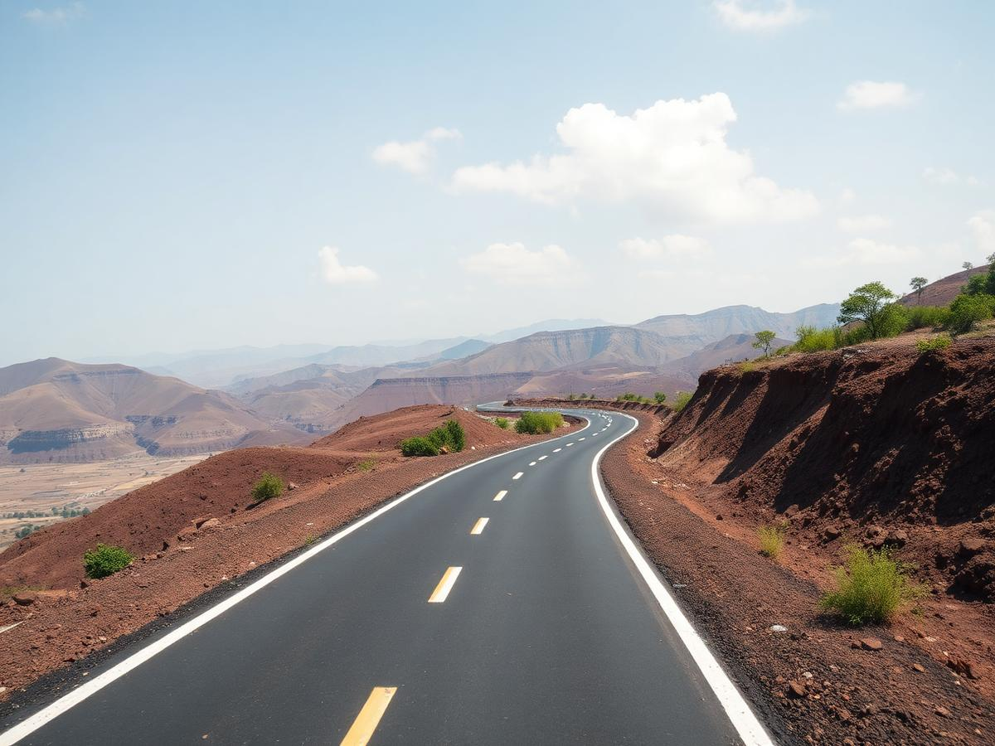
Residential · Commercial · Road & Infrastructure

7. Our Process
- Consultation — understanding your goals, site and budget.
- Planning & costing — transparent BOQ and schedule.
- Construction — disciplined site management and quality control.
- Handover — inspection, snag closure and after-sales support.

8. Contact
Office: Bisrate Gabriel, Addis Ababa, Ethiopia
Phone: +251 919 626 268
Email: info@aucontractor.et

